**2023-24 Cabin John Middle School Odyssey Of The Mind  
LONG-TERM PROBLEM SYNOPSES**

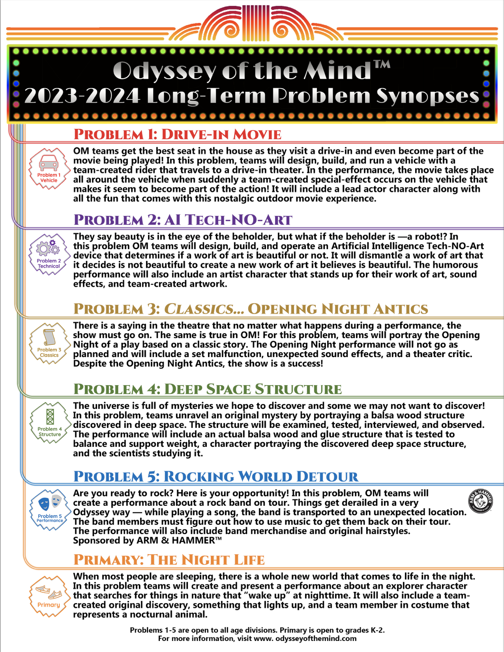

**2023-2024 Cabin John Middle School Odyssey Of The Mind**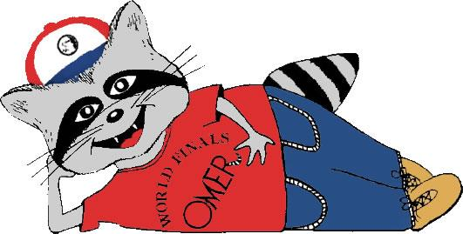

Coordinators: **Rachel Farnsworth & Alex Knight**

E-mail:[**CabinJohnOdyssey@gmail.com**](mailto:bellsmillodyssey@gmail.com)

Registration URL: <https://forms.gle/i28ThamFHpRsaDVX8>

**What is Odyssey of the Mind?**   
Odyssey of the Mind (OotM) is an international program aimed at developing creative problem solving skills in children of all ages (kindergarten through college). There are two general categories of problems: spontaneous and long-term. For spontaneous problems, children work as a team to solve a problem in a few minutes. For long-term problems, children work as a team over the course of several months to solve a more involved problem (see back for synopses of the long-term problems for this year).

Odyssey of the Mind is designed to align with STEM, Common Core, and 21st Century Skills initiative. The program encourages intellectual curiosity, teamwork, critical analysis of ideas, learning how to listen to one another, effective conflict resolution, flexible creative thinking, and on-stage performance skills. For more info: [odysseyofthemind.com](http://www.odysseyofthemind.com), and the Maryland state program website at [mdodyssey.org](http://www.mdodyssey.org).

**How does it Happen?**Success in the programdepends on *innovation*, *parent* *volunteerism*, and *hard work*. Student members will learn creative thinking and must also expect to put a lot of effort into their long-term problem. The program is run entirely by parent volunteers. The OotM coaches (all of whom will be trained) will provide spontaneous problems and offer teaching in skills relevant to the program. However, work on the long-term problem is entirely team-driven – no one but the team members can generate ideas for solving the problem. Parents who do not serve as coaches can instead volunteer to help with many other necessary tasks throughout the year. Teams of 5-7 students will be formed based on grade level, interests, child preferences, and balance.

**When and Where**Program meetings for 2023-24 will be at Cabin John on Fridays, typically from 3pm to 4:30pm. The fall meetings will begin on Friday, October 13. Beginning in January, teams may add a few weekend meetings at parents’ homes (depending on safe practices) to do additional work on the long-term problem for things like set and prop production. The Maryland State Tournament will be held on a weekend in Spring, likely late March. For any teams that qualify and decide to attend World Finals, those will be held in late May 2024.

**Who is Eligible?**All students are encouraged to participate. Middle school teams compete in Division 2.

**Cost**Currently, we do not have a registration fee. However, through the year, there might be expenses ranging from $20 - $60 per person for team expenses including t-shirts and tournament fees.

**Information Night, 7pm, Sept. 12th**  
Please join us at the information night, when we will introduce OotM and answer your questions: Meeting ID: 757 4958 4528

Password: CJMSOOTM

**Sign up by Friday, September 29th**   
Please go online to register at: [**https://forms.gle/SDmPyuSnogEzHpWJ7**](https://forms.gle/SDmPyuSnogEzHpWJ7)

After that, we can only accommodate additional children if there are open slots. Signing up your child also indicates willingness on the part of at least one parent or guardian to help in one of the volunteer roles.