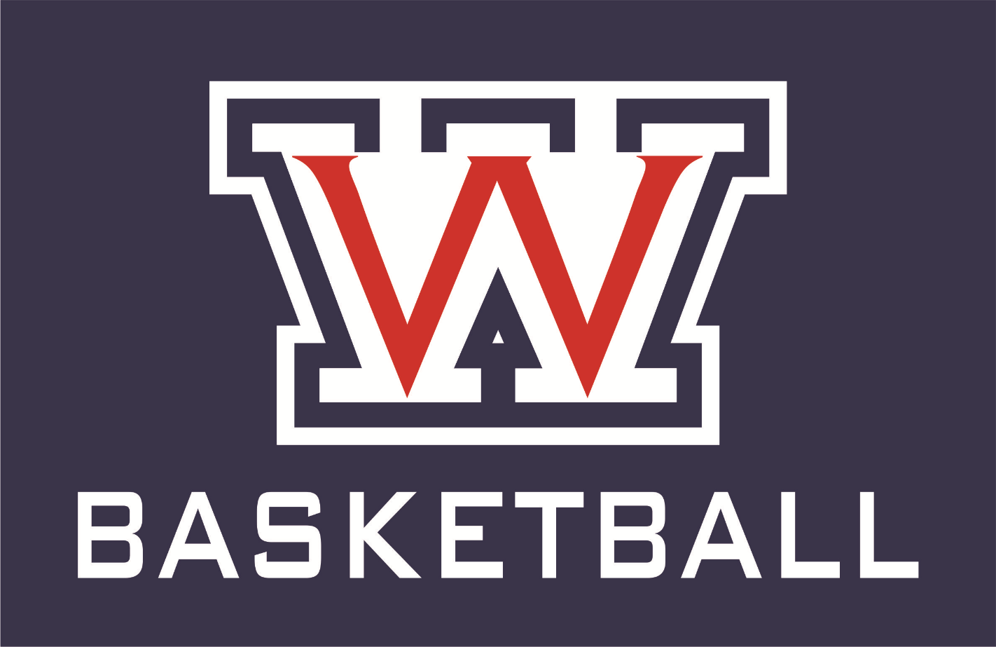

Your Wootton Boys’ Basketball team would like to invite you to Wootton High School on Friday January 5th for our Wootton Community Game at 7:15pm vs Clarksburg
and
Saturday January 6th from 10:30am- 12:00pm for our
Wootton Community Day Basketball Clinic.
Our coaching staff and players will be leading skill development stations and fun games during this time. The Wootton community is second to none and we want to continue to grow this strong culture. Thank you and look forward to seeing everyone.
We are Wootton!!!!!

