CABIN JOHN PTSA FAMILY NIGHT AT
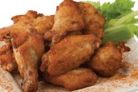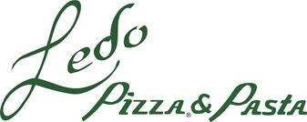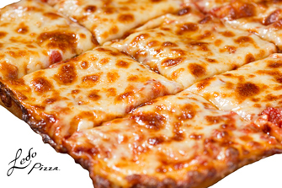

Enjoy a great family dinner while raising money for Cabin John PTSA
Wednesday, October 18
5-9pm
2 Locations:
Westlake Travilah Square
10301 Westlake Drive 10058 Darnestown Rd
Bethesda, MD 20817 North Potomac, MD 20850
301-469-6700 301-424-2700
CJ PTSA receives 20% of ALL dine-in when mentioning Cabin John MS!
CJ PTSA also receives 20% of takeout orders when mentioning Cabin John MS!
Call ahead for takeout!
Order Online at ledopizza.com
Bring a friend and tell your neighbors too!
20% of ALL PROCEEDS GO TO CJMS PTSA!

