Wootton Pom Information Meeting

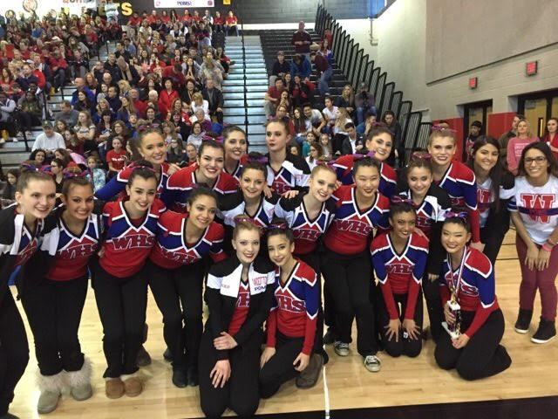

Please join us for information regarding try-outs and the upcoming season!

When: March 28th at 6:30 pm
Where: Room 183

