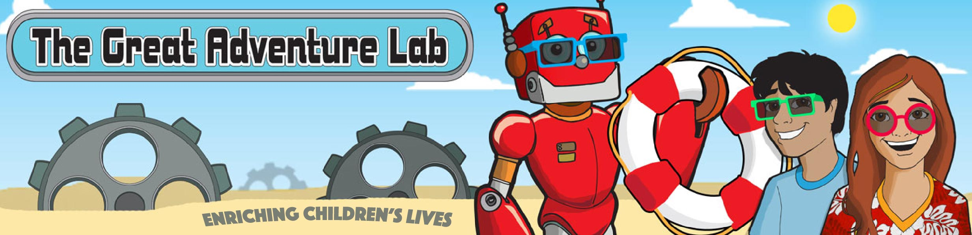
The GrAd Lab Classes at Cabin John MS!

http://tinyurl.com/W17-STEM-CJM

The Great Adventure Lab is an after-school science enrichment program. We’ve taught thousands of kids how to write their first robotics or video game programs (or both!). We do it all with a student-to-adult ratio of 7:1 for most classes. (You can find full descriptions, reviews and photos of all our classes and birthday parties at http://thegreatadventurelab.com.

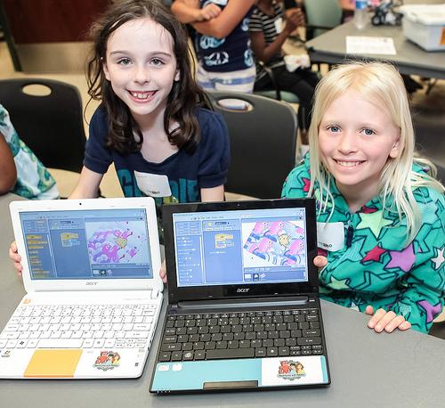
Video Game Programming A, Grades 6 - 8
Wed 3:15-4:15pm
Jan 11, 18, 25, Feb 1, 8, 15, 22

Ready to stretch beyond modding and try a powerful programming language? We’ll use basic commands, loops and more to create characters that move, talk, and interact. Each student will build his or her very own game and share it with friends!
Areas of Exploration: Programming, Multimedia, Storytelling, Music, Logic.
Class Format: Seven 60-min. meetings, once per week.
Tuition: $145 tuition + $5 materials fee per student; min 11 / max 12 students, 2 instructors, no aide.

