Cabin John Middle School
PTSA Sponsored
Back-to-School Picnic & Parents’ Social
Tuesday, September 13th 5-7 pm

Challenge your friends
at Bootcamp Obstacle Course & Hippo Chow Down
or Take pictures with your BFF

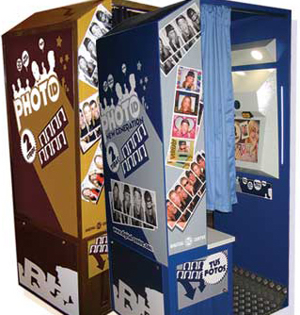

Buy dinner from Tally-Ho Restaurant, Soulbaby Cafe and Fred’s Ice Cream

Join the Fun!!!

