SCHOOL NIGHT EVENT

Hosted by your local

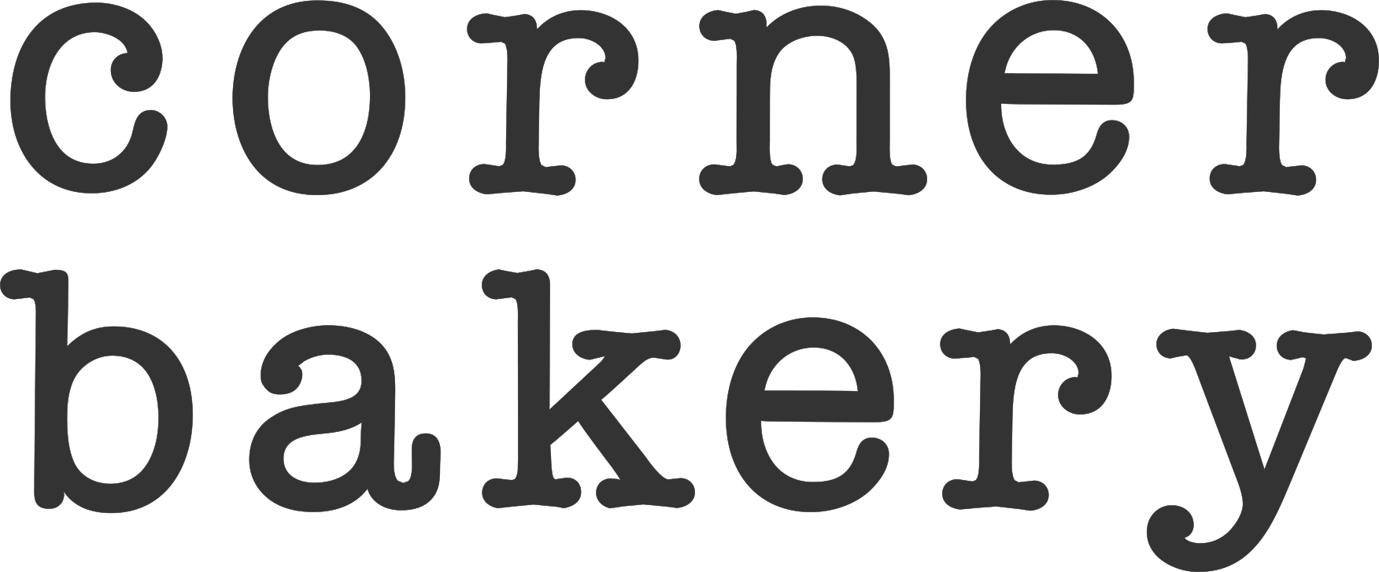

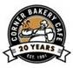

Thursday November 12th, 2015

Together we can help our teachers and their students by supporting the fundraiser! Corner Bakery will be giving 15% of all sales generated by the fundraiser to your school! So let’s have some fun and bring your friends and family for a late lunch or early dinner!

|  |  |  |  |  |  |  |  |  |  |  |
| --- | --- | --- | --- | --- | --- | --- | --- | --- | --- | --- |
| Corner Bakery Westlake Crossing | | | | |  | Corner Bakery Gaithersburg RIO | | | | |
|  |
|  |
|  |
|  |
|  |  |  |  |  |  |  |  |  |  |  |
|  | **10327 Westlake Dr.** | | |  |  |  | **1 Grand Corner Ave.** | | |  |
|  | **Bethesda, MD 20817** | | |  |  |  | **Gaithersburg, MD 20878** | | |  |
| **From: 4:00pm - 8:00pm** | | | | |  | **From: 4:00pm - 9:00pm** | | | | |