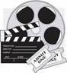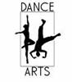
Calling all artists, photographers, poets, dancers,
musicians, movie-directors, writers, and playwrights!

We need YOU to represent CJMS
in the Reflections arts competition!
· Take a photograph
· write a story, play, or poem
· draw or paint a picture
· compose a song
· choreograph a dance
· film a video
You can even make entries for ALL the categories!
Just turn in a separate entry form for each entry.
Winning entries will go on to compete
at the county, state, and national levels!
The 2014-2015
National PTA Reflections theme is
The world would be a better place if...

If you’d like to be put on a list to receive
more information as it becomes available,
email tabatha@yeatts-lonske.com

