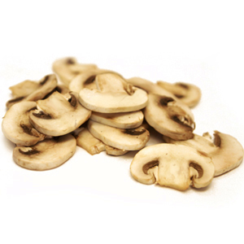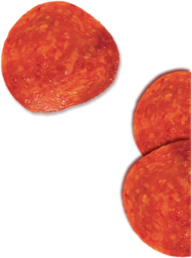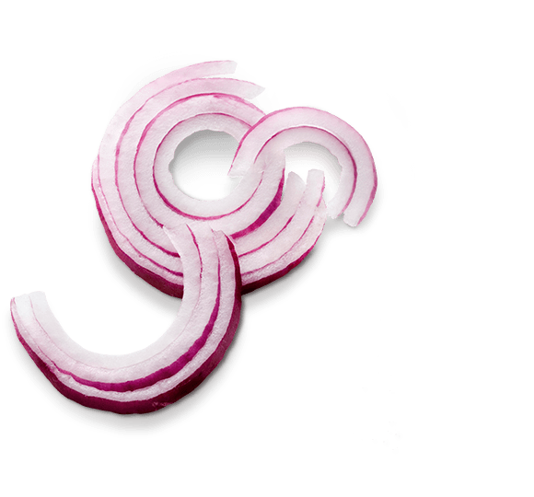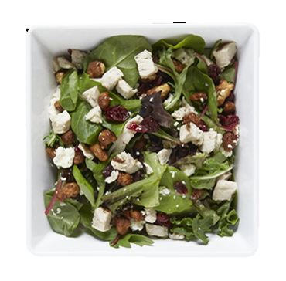

Pieology Gaithersburg

15780 Shady Grove Road

Gaithersburg, MD 20811

Cabin John MS Restaurant Night

Thank You for Your Support!!

Join Us

Show this flyer and Pieology will donate 25%

of your purchase on April 17, 2018 (4-9pm)

to Cabin John PTSA